UNIVERSITY OF ENGINEERING & TECHNOLOGY
Department of Computer Engineering
SUBMITTED BY | MIAN MUHAMMAD MOEEN
ROLL NO | 2025(CYS-111-B)
SECTION | B
SEMESTER | 4TH
SUBMITTED TO | HAFIZ MUHAMMAD MUBASHAR IMRAN
LAB | 7
SESSION | 2025-2029
SUBJECT | ARTIFICIAL INTELLIGENCE LAB

LAB 7 REPORT
CODE:-
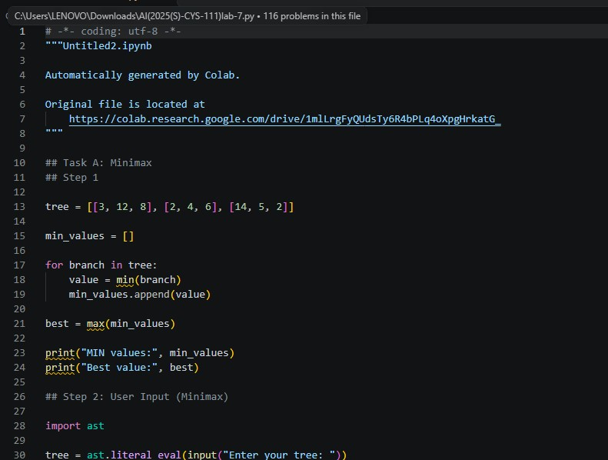
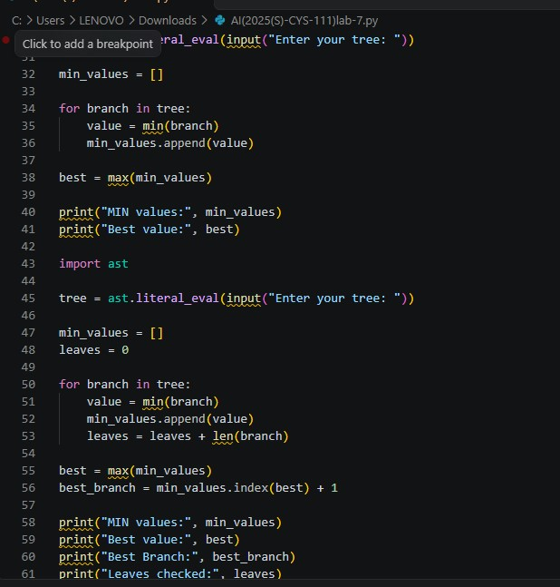
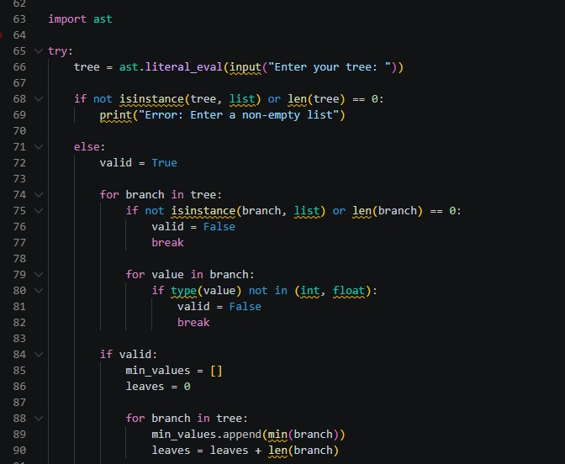
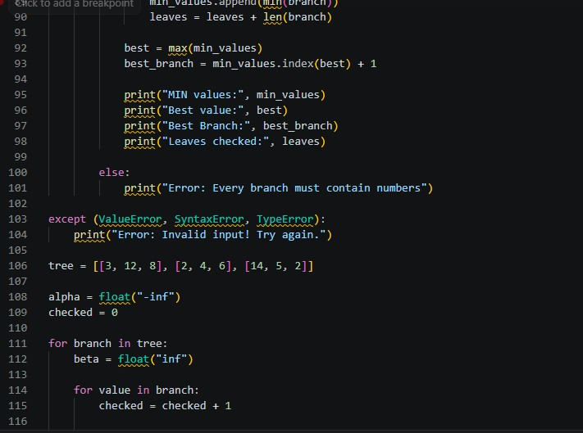
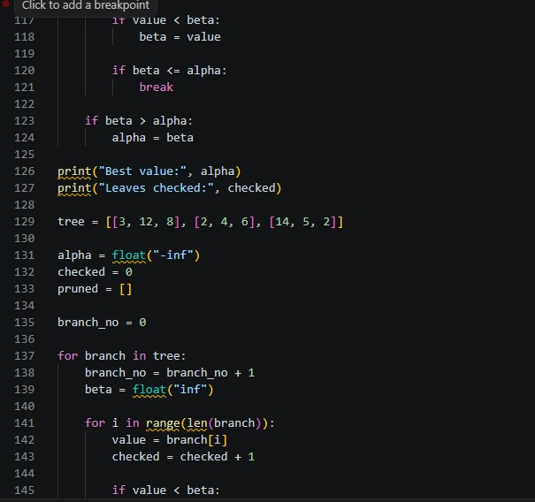
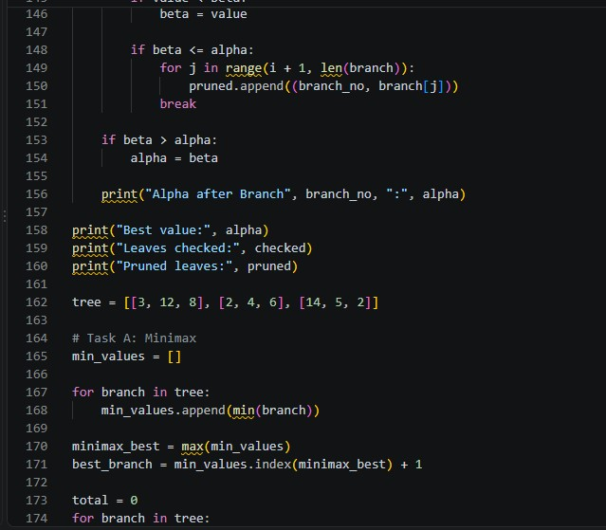
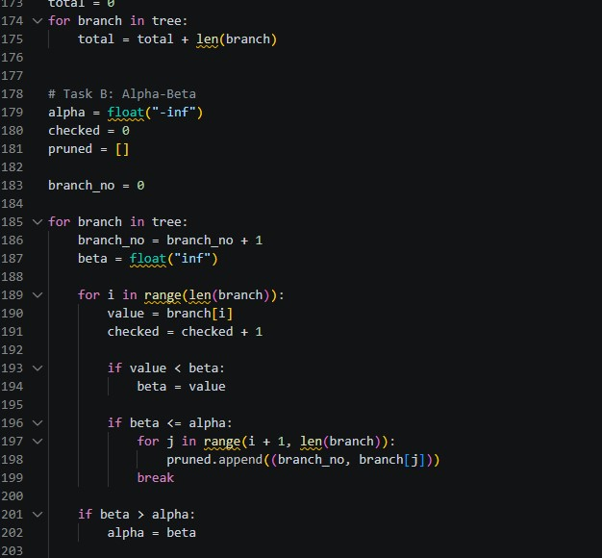
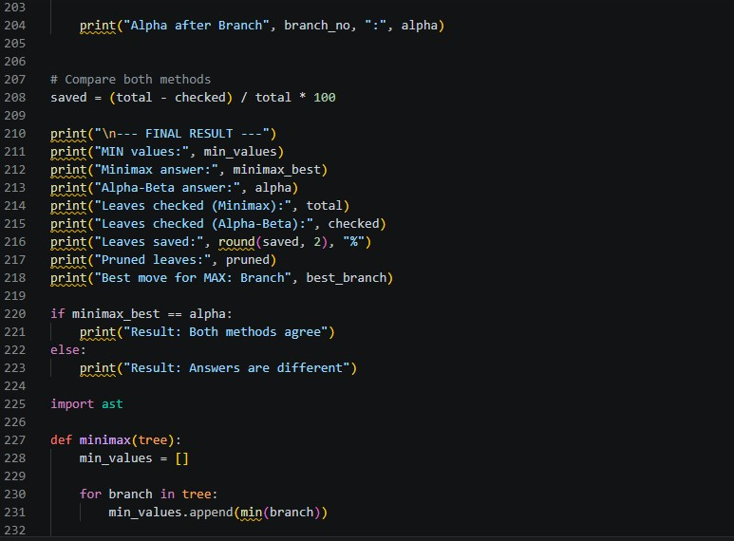
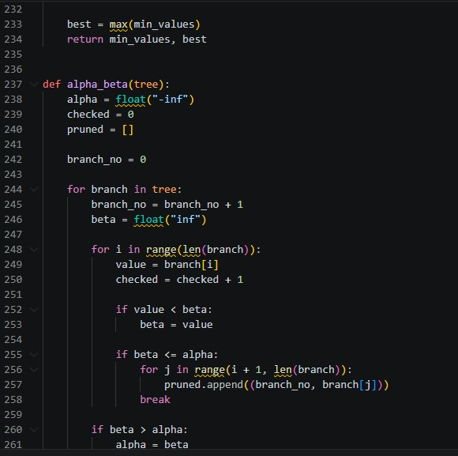
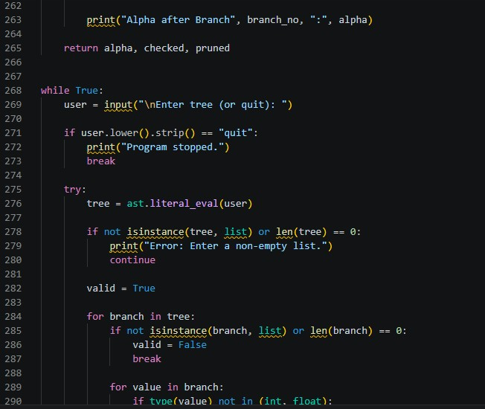
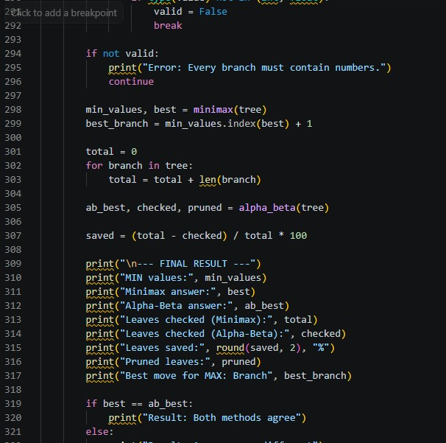
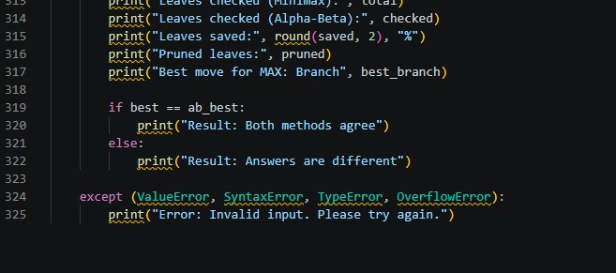
OUTPUT:-
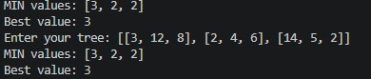

LAB REPORT – 07

MINIMAX AND ALPHA-BETA PRUNING

Adversarial Search in Artificial Intelligence

1. INTRODUCTION
Minimax and Alpha-Beta Pruning are important algorithms used in Artificial Intelligence for decision-making in two-player games.
In adversarial search, two players compete against each other. One player tries to achieve the highest possible score, while the other tries to achieve the lowest possible score.
The Minimax algorithm evaluates different possible moves and selects the best move for the MAX player, assuming that the MIN player always makes the best possible decision.
Alpha-Beta Pruning improves the Minimax algorithm by avoiding unnecessary calculations. It skips branches that cannot change the final decision.
In this lab, Python is used to implement both algorithms, calculate their results, compare their performance and understand how pruning reduces the number of leaves checked.

2. OBJECTIVES
The main objectives of this lab are:
- To understand adversarial search in Artificial Intelligence.
- To understand the working of the Minimax algorithm.
- To implement Minimax using Python.
- To understand the role of MAX and MIN players.
- To understand Alpha-Beta Pruning.
- To implement Alpha-Beta Pruning using Python.
- To compare both algorithms using different game trees.
- To calculate the number of leaves checked and pruned.
- To understand how input validation works in Python.
- To verify that both algorithms produce the same final answer.

3. THEORETICAL BACKGROUND

3.1 Adversarial Search
Adversarial search is a searching technique used when two or more players compete against each other.
Each player has different goals. One player tries to maximize the score, while the opponent tries to minimize it.
Example: Chess and Tic-Tac-Toe are examples of games that use adversarial search.

3.2 MAX Player
MAX is the player who wants to achieve the highest possible value.
MAX selects the largest value from the available MIN node values.

3.3 MIN Player
MIN is the opponent who wants to achieve the lowest possible value.
MIN selects the smallest value from its available leaves.

3.4 Game Tree
A game tree represents different possible moves in a game.
- Root node represents the MAX player.
- Branches represent different possible moves.
- MIN nodes represent the opponent's decisions.
- Leaf nodes contain the final numerical values.

3.5 Minimax Algorithm
Minimax is a decision-making algorithm that selects the best possible move by considering the opponent's best response.
Rules:
- MIN selects the smallest value.
- MAX selects the largest value.
Formula:
MIN Node:
MIN Value = Minimum of all child values.
MAX Node:
MAX Value = Maximum of all MIN node values.

3.6 Alpha-Beta Pruning
Alpha-Beta Pruning is an optimization technique of the Minimax algorithm.
It reduces unnecessary calculations by skipping branches that cannot improve the final result.
It uses two important variables:
Alpha (α): The best value that MAX can guarantee so far.
Beta (β): The best (lowest) value that MIN can achieve within the current branch.
Pruning Condition:
Beta ≤ Alpha
When this condition becomes true, the remaining leaves of that MIN branch are skipped.

3.7 Difference Between Minimax and Alpha-Beta
Minimax | Alpha-Beta Pruning
Checks every leaf. | Can skip unnecessary leaves.
Does not use alpha and beta. | Uses alpha and beta.
Performs more calculations. | Can perform fewer calculations.
Gives the best value for MAX. | Gives the same best value for MAX.
Does not prune branches. | Prunes unnecessary branches.

4. SOFTWARE AND TOOLS USED
Tool | Purpose
Python | Programming language
Google Colab | Writing and executing Python code
ast module | Converts user input into Python lists safely
Minimax Algorithm | Finds the best value for MAX
Alpha-Beta Pruning | Reduces unnecessary calculations
Python Lists | Store game trees and leaf values
Loops | Process branches and leaves
Conditional Statements | Apply decision-making and pruning rules

5. IMPLEMENTATION OF MINIMAX

5.1 Working Procedure
The Minimax algorithm follows these steps:
- Take a game tree as input.
- Read every branch of the tree.
- Find the smallest value in each branch using min().
- Store all MIN values in a list.
- Find the largest value using max().
- Identify the branch that provides the best value.
- Count all the leaves checked.
- Display the final result.

5.2 Example Input
tree = [[3, 12, 8], [2, 4, 6], [14, 5, 2]]

5.3 Manual Calculation of Minimax
Branch | Leaf Values | Minimum Value
Branch 1 | 3, 12, 8 | 3
Branch 2 | 2, 4, 6 | 2
Branch 3 | 14, 5, 2 | 2
MIN Values = [3, 2, 2]
MAX selects:
MAX = max(3, 2, 2)
Best Value = 3
Best Branch = Branch 1

5.4 Explanation of Python Commands
Command | Explanation
import ast | Imports the Python AST module.
input() | Takes input from the user.
ast.literal_eval() | Converts entered text into a Python list safely.
min(branch) | Finds the smallest value in a branch.
max(min_values) | Finds the largest MIN value.
append() | Adds an element to a list.
index() | Finds the position of a value.
len() | Counts the number of elements.
print() | Displays results.
return | Returns the result from a function.

6. IMPLEMENTATION OF ALPHA-BETA PRUNING

6.1 Working Procedure
- Initialize alpha with negative infinity.
- Initialize the checked counter with zero.
- Read each branch of the game tree.
- Initialize beta with positive infinity for every branch.
- Compare the leaf values and update beta.
- Check whether beta is less than or equal to alpha.
- If the condition is true, skip the remaining leaves.
- Update alpha after completing each branch.
- Count the checked and pruned leaves.
- Display the final result.

6.2 Example Input
tree = [[3, 12, 8], [2, 4, 6], [14, 5, 2]]

6.3 Alpha-Beta Manual Calculation
Initially:
Alpha = -Infinity
Branch 1:
- Check 3, 12 and 8.
- Minimum value = 3.
- Alpha becomes 3.
Branch 2:
- First leaf = 2.
- Beta becomes 2.
- Beta ≤ Alpha (2 ≤ 3).
- The remaining leaves 4 and 6 are pruned.
Branch 3:
- Check 14, 5 and 2.
- Minimum value = 2.
- Alpha remains 3.
Final result:
Description | Value
Minimax Answer | 3
Alpha-Beta Answer | 3
Total Leaves | 9
Leaves Checked | 7
Leaves Pruned | 2
Best Branch | Branch 1
Percentage of leaves saved:
Percentage Saved = (Pruned Leaves / Total Leaves) × 100
= (2 / 9) × 100
Percentage Saved = 22.22%

7. TASK A – MINIMAX TESTING AND HAND CALCULATIONS

7.1 Test 1: Given Tree
Input:
[[3, 12, 8], [2, 4, 6], [14, 5, 2]]
Branch | Values | MIN Value
1 | 3, 12, 8 | 3
2 | 2, 4, 6 | 2
3 | 14, 5, 2 | 2
MIN Values = [3, 2, 2]
MAX = max(3, 2, 2) = 3
Answer: Branch 1, Best Value = 3

7.2 Test 2: Negative Values
Input:
[[-3, 5], [-1, -4], [0, 2]]
Branch | Values | MIN Value
1 | -3, 5 | -3
2 | -1, -4 | -4
3 | 0, 2 | 0
MIN Values = [-3, -4, 0]
MAX = max(-3, -4, 0) = 0
Answer: Branch 3, Best Value = 0
Reason: MAX selects zero because it is the largest available MIN value.

7.3 Test 3: Single Branch and Single Leaf
Input:
[[7]]
Branch | Values | MIN Value
1 | 7 | 7
MIN Values = [7]
MAX = 7
Answer: Branch 1, Best Value = 7
Reason: There is only one possible branch and one leaf, so the answer is 7.

8. TASK B – ALPHA-BETA PRUNING TESTING

8.1 Alpha-Beta Calculation
For the first test tree:
[[3, 12, 8], [2, 4, 6], [14, 5, 2]]
Branch | Leaf Checked | Beta | Alpha | Action
1 | 3 | 3 | -∞ | Continue
1 | 12 | 3 | -∞ | Continue
1 | 8 | 3 | 3 | Branch completed
2 | 2 | 2 | 3 | Prune 4 and 6
3 | 14 | 14 | 3 | Continue
3 | 5 | 5 | 3 | Continue
3 | 2 | 2 | 3 | No remaining leaves
Final Alpha = 3
Leaves Checked = 7
Pruned Leaves = 2

9. TASK C – COMPLETED TESTING TABLE
The following results are calculated using the Minimax and Alpha-Beta logic implemented in the submitted Python program.
No. | Tree Typed | Minimax | Alpha-Beta | Leaves Checked | Pruned Leaves | Do You Agree? Why?
1 | [[3,12,8],[2,4,6],[14,5,2]] | 3 | 3 | 7/9 | 2 (4,6) | Yes, both give 3.
2 | [[5,6],[7,4,5],[3]] | 5 | 5 | 5/6 | 1 (5) | Yes, both give 5.
3 | [[2,4,6],[3,12,8],[14,5,2]] | 3 | 3 | 9/9 | None | Yes, both give 3.
4 | [[9,8,7],[1,2,3],[2,5,6]] | 7 | 7 | 5/9 | 4 (2,3,5,6) | Yes, both give 7.
5 | [[-3,5],[-1,-4],[0,2]] | 0 | 0 | 6/6 | None | Yes, both give 0.
6 | [[7]] | 7 | 7 | 1/1 | None | Yes, only one leaf exists.
7 | [[1,2],[]] | Invalid | Invalid | N/A | N/A | Yes, empty branch is rejected.
8 | [[9,10,11],[1,2,3],[2,5,6],[0,4,7]] | 9 | 9 | 6/12 | 6 (2,3,5,6,4,7) | Yes, both give 9.
9 | [[1,2,3],[4,5,6],[7,8,9]] | 1 | 1 | 9/9 | None | Yes, both give 1.
Note: For Test 7, the program displays an error because one branch is empty. It does not calculate a Minimax or Alpha-Beta result for invalid input.

9.1 Explanation of Testing Results
Test 1: Alpha-Beta checks seven leaves and prunes two leaves because the second branch cannot improve MAX's existing value.
Test 2: Alpha-Beta checks five leaves and prunes one leaf from Branch 2.
Test 3: No leaves are pruned because the branches are arranged in an order that does not create an earlier cutoff.
Test 4: Four leaves are pruned because the first branch establishes a high alpha value of 7.
Test 5: Negative values are processed correctly. No leaves are pruned.
Test 6: Only one leaf exists, so both algorithms return 7.
Test 7: The empty branch is invalid. Input validation prevents the program from processing it.
Test 8: The first branch establishes alpha = 9. The other three branches are pruned after checking their first leaves. Six leaves are saved.
Test 9: No pruning occurs because each leaf in the remaining branches is checked before a cutoff can happen.

9.2 Percentage of Leaves Saved
Formula:
Percentage Saved = ((Total Leaves - Leaves Checked) / Total Leaves) × 100
Test | Total Leaves | Checked | Pruned | Percentage Saved
1 | 9 | 7 | 2 | 22.22%
2 | 6 | 5 | 1 | 16.67%
3 | 9 | 9 | 0 | 0%
4 | 9 | 5 | 4 | 44.44%
5 | 6 | 6 | 0 | 0%
6 | 1 | 1 | 0 | 0%
7 | N/A | N/A | N/A | N/A
8 | 12 | 6 | 6 | 50%
9 | 9 | 9 | 0 | 0%

10. WRITTEN QUESTIONS AND ANSWERS

Q1. Minimax assumes that the opponent plays perfectly. What does MAX still get if the opponent makes a mistake?
Minimax selects the best move by assuming that the opponent will always make the best possible decision. If the opponent makes a mistake, MAX may receive a better result than expected. MAX can take advantage of the opponent's wrong move and achieve a higher score. Therefore, Minimax provides a safe decision against a perfect opponent.

Q2. Why does Alpha-Beta give the same answer as Minimax? Explain using one pruned leaf from your table.
Alpha-Beta gives the same answer because it skips only those leaves that cannot change the final decision. For example, in Test 1, MAX already has an alpha value of 3. In Branch 2, the first leaf is 2, which is smaller than alpha. Therefore, the remaining leaves 4 and 6 are skipped. This branch cannot give MAX a better result. Both algorithms return 3.

Q3. Compare Tests 1 and 3. They have the same leaves, but the number of checked leaves is different. Why?
Both tests contain the same numbers, but their branch order is different. In Test 1, the first branch establishes alpha = 3. When the algorithm reaches the second branch, it finds 2 and prunes the remaining leaves. In Test 3, the first branch establishes alpha = 2, and the second branch has a minimum value of 3. The final branch does not have any remaining leaves after the cutoff condition becomes true. Therefore, Test 1 checks 7 leaves while Test 3 checks all 9 leaves.

Q4. Why is pruning important for games like Tic-Tac-Toe or Chess?
Pruning is important because games can have a very large number of possible moves. Checking every possible move requires considerable time and computational resources. Alpha-Beta Pruning skips unnecessary branches and reduces calculations. It allows the computer to search deeper into the game tree in less time. This makes decision-making more efficient.

Q5. Minimax plans for the worst-case opponent. Give one example from cybersecurity where a defender should think in this way.
A firewall administrator should think about the worst possible actions of an attacker. The administrator should assume that an attacker will try different methods to bypass security. Therefore, strong firewall rules, access controls, authentication and monitoring should be implemented. This approach helps protect the network even when an attacker uses the best possible attack strategy.

11. INPUT VALIDATION AND ERROR HANDLING
Input validation checks whether the user has entered a correct game tree.
The submitted program uses:
- ast.literal_eval() to convert input into a Python list.
- isinstance() to check whether the input is a list.
- len() to check whether the list is empty.
- type(value) to check whether each leaf is an integer or float.
- try and except to handle invalid input errors.
- continue to ask the user for another input.
- break to stop the program when the user enters quit.
Example of invalid input:
[[1, 2], []]
Output:
Error: Every branch must contain numbers.
This happens because the second branch is empty.

12. IMPORTANT PYTHON FUNCTIONS AND VARIABLES
Function / Variable | Purpose
minimax(tree) | Calculates MIN values and the best MAX value.
alpha_beta(tree) | Performs Alpha-Beta Pruning.
alpha | Stores the best value for MAX so far.
beta | Stores the smallest value found in the current MIN branch.
checked | Counts the leaves examined by Alpha-Beta.
pruned | Stores the skipped leaves.
min_values | Stores the minimum value of each branch.
best | Stores the final Minimax value.
best_branch | Stores the selected branch number.
total | Counts all leaves in the tree.
saved | Calculates the percentage of leaves saved.

13. FLOWCHARTS

13.1 Minimax Algorithm Flowchart
START
|
v
Enter Game Tree
|
v
Read Every Branch
|
v
Find Minimum Value
of Each Branch
|
v
Store MIN Values
|
v
Find Maximum Value
|
v
Identify Best Branch
|
v
Display Result
|
v
END

13.2 Alpha-Beta Pruning Flowchart
START
|
v
Enter Game Tree
|
v
Initialize Alpha
to -Infinity
|
v
Select MIN Branch
|
v
Initialize Beta
to +Infinity
|
v
Read Next Leaf
|
v
Update Beta
|
v
Is Beta <= Alpha?
/ \
YES NO
| |
v v
Prune Rest Read Next
of Branch Leaf
| |
v |
Update Alpha <-+
|
v
Next Branch
|
v
Display Result
|
v
END

14. RESULTS AND DISCUSSION
The Minimax and Alpha-Beta Pruning algorithms were successfully implemented using Python.
Different game trees were tested, including positive values, negative values, a single branch, an invalid tree and two additional custom trees.
The results demonstrate that both algorithms produce the same best value for every valid test case.
Alpha-Beta Pruning reduces the number of leaves that need to be checked. In Test 8, it checks only 6 out of 12 leaves and saves 50% of the calculations.
However, the amount of pruning depends on the order of branches and leaf values. Some test cases do not produce any pruning.
The input validation mechanism also prevents invalid trees from being processed.

15. CONCLUSION
In this lab, I learned how Minimax and Alpha-Beta Pruning work in Artificial Intelligence.
I implemented both algorithms using Python and tested them with different game trees.
Minimax calculates the best possible value for MAX by selecting the minimum value from each branch and then selecting the maximum among those values.
Alpha-Beta Pruning improves this process by skipping unnecessary leaves using alpha and beta values.
The practical results confirmed that both algorithms produce the same final answer for valid inputs. Alpha-Beta Pruning can reduce computational work and improve search efficiency.
Therefore, this lab helped me understand adversarial search, decision-making, optimization and the practical implementation of search algorithms in Python.

16. SCREENSHOTS / PRACTICAL EVIDENCE
Screenshot 1: Minimax Implementation
[Insert screenshot of your Minimax code and output from Google Colab.]
Screenshot 2: Alpha-Beta Pruning Implementation
[Insert screenshot showing alpha, beta and pruned leaves.]
Screenshot 3: Testing Table – Test Cases 1–4
[Insert screenshot of program outputs for the first four test cases.]
Screenshot 4: Testing Table – Test Cases 5–9
[Insert screenshot of program outputs for the remaining test cases.]
Screenshot 5: Invalid Input Testing
[Insert screenshot showing the error message for an empty branch.]

17. REFERENCES
- CYS-241L Artificial Intelligence, Lab 07: Minimax and Alpha-Beta Pruning – Lab Manual.
- Python Official Documentation – Python Lists and Functions.
- Python AST Module Documentation.
- Class Lectures and Practical Lab Exercises.

END OF LAB REPORT

